The overseas tour of Sergei Yesenin and Isadora Duncan: facts and fables

Панорамная экскурсия по музею: https://esenin-museum.ru/panorama

Виртуальная экскурсия по экспозиции музея: https://esenin-museum.ru/virtual_tour

Электронный фонд музея: https://esenin.museum-online.moscow/

1. Lost in Translation.

Isadora Duncan, an outstanding American dancer, came to the RSFSR in 1921 to teach soviet children her philosophy of modern dance.

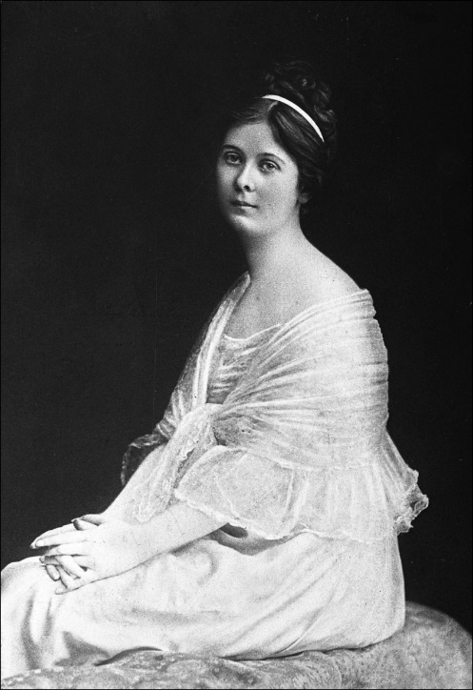

Read the passage and compare Isadora’s speech with the words of her interpreter. Whose style is more heartfelt and why?

– Children, I'm not going to learn you to dance: you will dance when you want and those dances, which will be suggested by your wishes, my little ones. I just want you to fly as birds, to bend as young trees under the wind, to be glad as a May morning, a butterfly, a froglet in the dew, to breathe free as clouds, to jump easy and quiet as a gray cat… Translate, – she addresses to the translator and political instructor of the school, tov. Grudsky.
– Детки, – переводит Грудский, – товарищ Изадора вовсе не собирается обучать вас танцам, потому что танцульки являются достоянием гниющей Европы. Товарищ Изадора научит вас махать руками, как птицы, ластиться вроде кошки, прыгать по-лягушиному, то есть, в общем и целом, подражать жестикуляции зверей…

(Yury Annenkov. A Tale of Nonsense).
____________________________________________________________________________________________________________________________________________________________________________________________________________
________________________________________________________________________________________________________________________________________________________________________________________________________________________________________________________________________________________________________________________________________________________________________________________________________________________

2. A little passport amendment.

Find the stand “Foreign travel of Sergei Yesenin”: https://esenin-museum.ru/virtual_tour.
The fortuneteller predicted Duncan's imminent marriage immediately before her trip to the RSFSR. Isadora couldn’t believe it, because she hated the institution of marriage, but her meeting with Sergei Yesenin changed this point of view. However, the bride was embarrassed by her age: she was 17 years older than the groom.
Before the registration, she showed her passport to her interpreter, Ilya Schneider, and asked:

«– Could you correct something here?
I didn’t understand, but she stood in front of me, smiling shyly, and pointed the finger at the date of her birth, written in black ink...
– Well, I have the ink, – I said, – but I think, it is not necessary...»

(Ilya Schneider. Meeting Yesenin)

Do you think it was possible to correct the official document in those days? Why?

________________________________________________________________________________________________________________________________________________________________________________________________________________________________________________________________________________________________________________________________________________________________________________________________________________________

3. “Paint It Black”.

“The Black Man” is a famous poem of Yesenin. The idea came to the poet during the overseas tour (1922–1923), when he was really homesick. Also, Yesenin mentioned, that he was fascinated by Pushkin’s “little tragedy” – “Mozart and Salieri”.

This black man
Runs his fingers over a vile book,
And, twangling above me,
Like a sleepy monk over a corpse,
Reads a life
Of some drunken wretch,
Filling my heart with longing and despair.
The black man,
Oh black man.
……………………………………………

The moon has died.
Dawn glimmers in the window.
Ah, night!
What, night, what have you ruined?
I stand top-hatted.
No one is with me.
I am alone...
And the mirror is broken.

American reporter Walter Duranty, Isadora's friend, understood the poem in this way:

«The poem was raw and brutal but alive and true. It described the feelings of a drunkard, who was haunted by the face of a negro grinning at him. The face was not unfriendly but it as everywhere – looking over his shoulder in the mirror when he shaved, beside him on the pillow in his bed, poised between his shoes in the morning when he got up to put them on.
I knew the story of this poem. The negro face was that of Claude McKaye, the colored poet who had visited Moscow a year or so before and had been a friend of Yesenin.»

(Walter Duranty. I Write As I Please)

Do you think, Duranty’s rendering is accurate? Why?

____________________________________________________________________________________________________________________________________________________________________________________________________________________________________________________________________________________________________________________________________________________________________________________________________________________________________________________________________________________________________________________________________________________________________________________________________________________________________
Try to remember some fixed expressions with the word "black" (the pictures can help you).
Make a few sentences using the phraseological units.

BLACK

____________________________________________________________________________________________________________________________________________________________________________________________________________________________________________________________________________________________________________________________________________________________________________________________________________________________________________________________________________________________________________________________________________________________________________________________________________________________________________________________________________________________________________________________________________________________________________

4. “The Land of Scoundrels”.
Poem text: https://rustih.ru/sergej-esenin-strana-negodyaev/.

Yesenin also began to work on the poem “The Land of Scoundrels” abroad. The poet often wrote about topical problems, and his contemporaries considered some of his characters as real historical figures under the fake names.

Try to identify real people by the descriptions:

Commissar Chekistov – ____________________  There is nothing more useless and hypocritical,  Than your Russian plain man!  If he lives in the province of Ryazan,  He ain’t got care for Tula.  A famous Russian revolutionary, who masterminded his own doctrine within the framework of Marxism, but he was expelled from the USSR. It is easy to recognize him in the old photographs because of the pince-nez and curly hair.  Nomakh – _____________________  I want to bring together those,  Who’s getting fatter on Marx’s, like Yankees:  We’ll be seeing their courage and smiles,  When tanks of our own mobilise.  An anarchist revolutionary, whose ancestors originated from the Zaporozhian Cossacks. He was known among the soldiers as ‘Bat'ko’. His ashes were scattered at Père Lachaise, a famous French cemetery, not far from the ashes of Isadora Duncan. | Felix Dzerzhinsky  Ivan Mazepa  Nestor Makhno  Mikhail Frunze  Mikhail Tukhachevsky  Lev Trotsky  Alexander Antonov

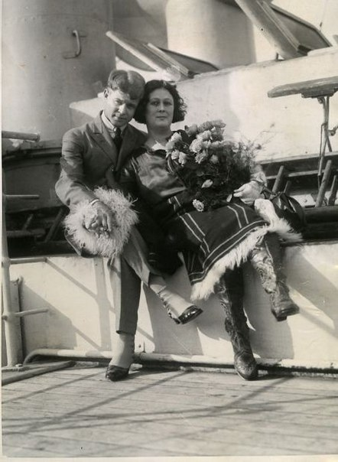

5. Dubious glory.

In September 1922, Yesenin and Duncan went off on a six-day journey from France to the USA on board the liner "Paris":

«The liner, which was as tall as a high-rise building, carried 700-800 passengers. There is a restaurant, a bar and a cafe, swimming pools, cinema halls, dance halls and even music halls for first- and second-class passengers. There are broad streets, illuminated by electric light of the shop windows. Printing presses clutter, typing daily newspapers. The bulls bellow – the restaurants need fresh meat ongoing. People play tennis and football. If someone wants to reach New York City a day earlier, they can fly away by plane from the upper deck. Every night all clocks on the ship are turned backward one hour.»

(Ilya Schneider. Meeting Yesenin).

Imagine that you are a passenger of such a liner; reflect what else you need for a comfortable trip and what is unnecessary?

_____________________________________  _____________________________________  _____________________________________ | ______________________________________  ______________________________________  ______________________________________

Yesenin said about the USA:

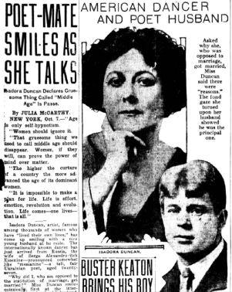
«Once I saw a delivery boy, and my photos were on all the newspaper covers. I felt my heart skip a beat. This is glory which crossed the ocean! I bought about a score of newspapers, according to the number of those whom I could make such gifts. I asked someone to translate the signature under the portrait. Then I heard:
“Sergei Yesenin, a Russian peasant, the husband of the famous, incomparable, charming dancer Isadora Duncan, whose immortal talent...” and so on …»

(Vsevolod Rozhdestvensky. Recollections of Yesenin).

Imagine Yesenin’s reaction to these words.
________________________________________________________________________________________________________________________________________________________________________________________________________________________________________________________________________________
Why do you think Duncan decided to leave her Moscow dancing school and go on a foreign tour?

She wanted to:

– get a certificate of right to inheritance of sth.
– raise money for her dance school
– publish Yesenin's verses abroad
– distract the poet’s attention from a bad company in Moscow
– save Yesenin from repressions
– settle abroad with Yesenin forever
– another variant:______________________________________________________

6. “America the Beautiful”.

Sergei Yesenin visited plenty of American cities.
Here is his path: New York City, Boston, Chicago, New York City, Indianapolis, Louisville, Milwaukee, Kansas City, St. Louis, Memphis, Detroit, Cleveland, Baltimore, New York City, Toledo, Toronto.

Draw a diagram of his voyage.

Write down some known facts about any burg.

____________________________________________________________________________________________________________________________________________________________________________________________________________________________________________________________________________________________________________________________________________________________________________________________________________________________________________________________________________________________________________________________________________________________________________________________________________________________________

Result

You are a representative of the Moscow State Museum of Sergei Yesenin.
Send a letter to the Isadora & Raymond Duncan Dance Research Center in Athens with a proposal for collaboration and think of a potentially interesting common projects.





